 | WORK ORDER  RO #: ____________________________ | Drop-Off Date: ______________  Completion Date: ____________  IG: ________________________  TikTok: _____________________  How Heard of Us: ___________________________

CLIENT INFORMATION | VEHICLE INFORMATION
Name: ____________________________________  Phone: __________________________________  Email: ___________________________________ | Year: _____________ Make: __________________________  Model: ____________ Submodel:______________ Trim: ______________  Color: ____________ Plate: ______________  VIN: __________________________________________________________
Mileage In: ____________ Intake Staff: __________________ | Installer: ____________________ IST: ____________________

PAINT PROTECTION FILM | WINDOW TINT | CERAMIC COATING | ADD-ONS
FILM TYPE  ☐ Ultimate Plus ☐ Ultimate Fusion  ☐ Stealth ☐ Color PPF  Color / Supplier: ____________________  STD ☐ EXT ☐  PACKAGE / COVERAGE  ☐ Full Coverage ☐ Full Front  ☐ Full Front + Rockers ☐ Track Pack  ☐ Partial Front ☐ Wear and Tear  ☐ Hood Full ☐ Hood Partial  ☐ All Doors ☐ Single Door  ☐ Rockers ☐ Door Cups / Edges  ☐ Headlights ☐ Fog Lights  ☐ Taillights ☐ Mirror Caps  ☐ A/B/C/D Pillars ☐ Roof  ☐ Spoiler ☐ Luggage Area  ☐ Interior Console ☐ Interior Trim  Individual Panels / Notes:  ______________________________  ______________________________  Total Price: $ __________________ | FILM  ☐ CS ☐ XR Black ☐ XR Plus  SHADE + POSITION (CIRCLE)  W = Windshield XR Black / Plus only  70% FS RS R SR SS W  55% FS RS R SR SS W  35% FS RS R SR SS W  30% FS RS R SR SS  20% FS RS R SR SS  15% FS RS R SR SS  05% FS RS R SR SS  Total Price: $ _______________ | PRODUCT  ☐ Fusion Lite  ☐ Fusion Classic  ☐ Fusion Premium V2  ☐ Fusion Satin  SURFACES  ☐ Paint ☐ PPF  ☐ Glass ☐ Trim / Plastic  ☐ Rim Faces ☐ Rims Off  ☐ Interior ☐ Seats  ☐ Engine Bay  Total Price: $ ____________ | WPF  ☐ Price: $ ____________  TINTED LIGHTS  50% 35% 25%  Front: circle above  50% 35% 25%  Rear: circle above  Film: _____________________  Price: $ ______________  SCREEN PROTECTOR  ☐ Satin ☐ Gloss  Price: $ ______________  REMOVE PPF **(2)  Panels: __________________________  Price: $ ______________  TOTAL ADD-ONS: $________________

ADDITIONAL REQUESTS / SPECIAL INSTRUCTIONS
_______________________________________________________________________________________________________________________________
_______________________________________________________________________________________________________________________________

Non-Refundable Deposit: $________________ Initials: __________ | TOTAL PRICE: $__________________________ Initials: ____________

JOB INSTRUCTIONS - AUTHORIZED ACTIONS FOR THIS VEHICLE
☐ Remove Emblems (F / S / R) *(1)  ☐ Paint Emblems Color: _____________ Finish: Satin / Gloss  ☐ Install Emblems Back On (F / S / R)  ☐ Small Letter Emblems NOT Reinstalled *(1)  ☐ Remove Handles (Y / N) $500 upcharge *(1)  ☐ Remove Trim Pieces *(1) | ☐ Remove Headlights / Taillights *(1)  ☐ Remove Side Marker Signals (Y / N) *(1)  ☐ Remove Bumper (F / R) *(1)  ☐ Remove Roof / Trunk Antenna *(1)  ☐ Wrap Between Bumper and Fenders  ☐ Dent Repair  Roll IDs: ___________________________________
*(1) LIABILITY NOTICE: Nashville ClearBra LLC will not be held liable for broken items, panels, screws, clips, retainers, emblems, leaks, trim, check engine lights, warning codes, or any other damage from or during the removal of authorized parts on this vehicle. Initials *: ________

DROP-OFF SIGNATURE
By signing below, the client authorizes all services listed on page one, confirms all information is correct, and acknowledges all terms on page two.
Client Signature: ________________________________ Print Name: _______________________ Date: _____________

TERMS AND CONDITIONS
Please remove all personal items prior to your appointment. Although we will take the utmost care with anything left inside your vehicle, we cannot be held responsible / liable for any items left behind in the vehicle that are lost, broken or stolen while in our possession.

Pre-Existing Damage: This job or installation is deemed completed and invoiced when signed below by customer and services have been completed that are listed on the first page of this agreement unless noted in writing. Customer's signature acknowledges the damage identified below as pre-existing and will not hold Nashville ClearBra LLC. liable. Some damages may have been missed during inspection and Nashville ClearBra LLC. will not be held liable for any pre-existing damages seen or not seen upon our inspection shown below.
Initials: ________

Authorization: I am the owner of the vehicle described on this document (the "Vehicle") or have been authorized by the owner to make the representations, promises and covenants provided herein and signed for above. I have removed all valuable articles from the vehicle, and Nashville ClearBra LLC. shall bear no responsibility for loss due to theft, fire, or any other cause beyond Nashville ClearBra's control. In the event of any damage done to a vehicle while in possession of Nashville ClearBra LLC., I agree to allow Nashville ClearBra LLC. to repair said damage using vendor(s) selected by Nashville ClearBra LLC. Nashville ClearBra cannot be responsible for any electrical/mechanical or engine components during routine service or installation provided. Every precaution will of course be taken to prevent such malfunction.

**(2) Paint Peeling: Nashville ClearBra LLC. will not be liable for any paint peeling / coming off during installation / removal of film. Initials **: ________

***(3) Window Tint: Nashville ClearBra LLC. will not be liable for your choice to tint on front windshield / front side windows based on local regulations, or tickets you may receive. We will not be held liable for any electronic issues when installing front windshield or defroster de-lamination when removing tint. Initials ***: ________

Vehicle Damage Diagram - Client or staff: mark any known pre-existing damage using defect codes from legend
DEFECT CODES  SH Swirls / Holograms  WS Water Spots  OX Oxidation  CF Clear Coat Failure  DS Deep Scratch  BD Bird Droppings  RP Rough Paint  PT Paint Transfer  UD Unknown Defect  PC Paint Chip  DD Dings / Dents  GC Glass Chip  GS Glass Scratch  CR Curb Rash  WD Wheel / Rim Damage | 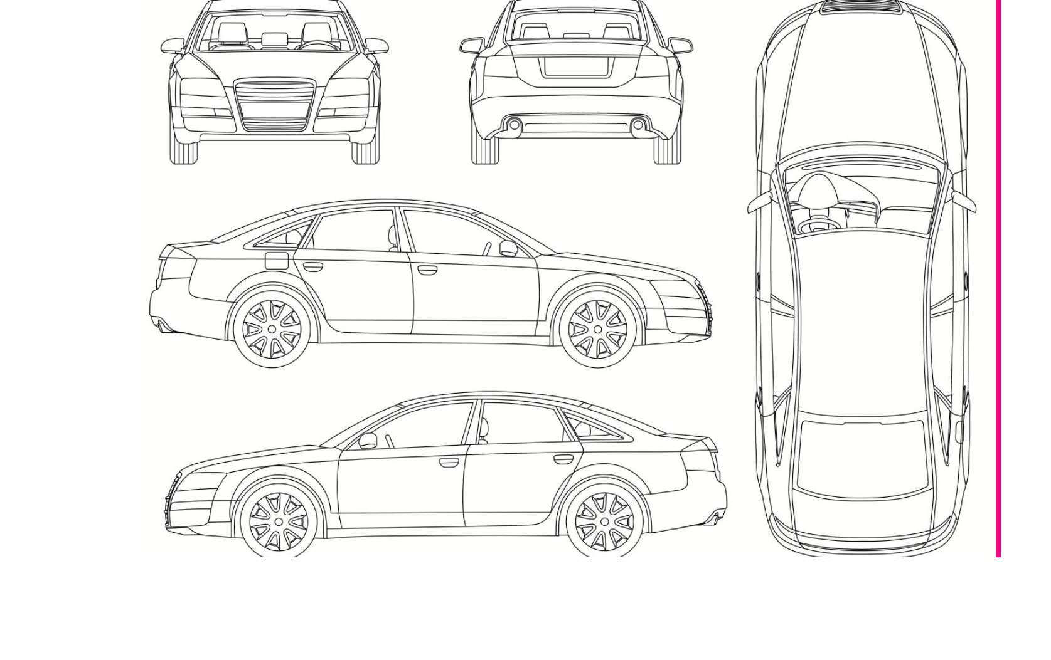

NOTES / PRE-EXISTING DAMAGE NOTES
______________________________________________________________________________________________________________________

UPON COMPLETION AND DELIVERY - TERMS
Workmanship Guarantee: Nashville ClearBra LLC. provides a lifetime workmanship warranty on all PPF and TINT installations, unless noted in writing on this agreement during the lifetime of your ownership on this vehicle. This covers bubbles that don't go away, multiple grits under film, edges peeling, PPF edges coming off edge via pressure washer. Nashville ClearBra LLC. will trim, pop or replace affected areas, upon our discretion free of charge.

Payment: Payment by cash, credit card or debit card is due and expected upon completion of work unless other arrangements are agreed to in writing ahead of time. No personal or business cheques are accepted. Upon delivery of the Vehicle and rendering the service(s) complete, I am accepting the work performed by Nashville ClearBra LLC. as complete and in timely compliance of our agreement. I am satisfied with the condition of services or work performed and condition of the vehicle upon pick up by signing below unless stated above in notes and initialed by client and manager.

COMPLETION / PICKUP SIGNATURE
Client Signature: ________________________________ Print Name: _______________________ Date: _____________ Mileage Out: ___________

